Dear Interested Hockey Tournament Teams:
The Heitz 61 Memorial Foundation will host our tenth Heitz of Heaven Hockey Tournament the weekend of September 10-11, 2022, at RMU Island Sports Center. We would be honored to have your team participate in our tournament this year. Following are the details:
- Game schedule will begin Saturday, September 10th, at approximately 7:00 am and end on Sunday, September 11th at approximately 4:00 pm.
- All games will be played at RMU Island Sports Center
- There will be two Squirt (10U) divisions
- Each team is guaranteed to play four games.
- Hockey jerseys will be supplied to the teams and is included in the registration fee.
- USA Hockey rules apply and EMT will be present at all games
- To the extent team pairings match to PAHL requirements, some games may be used toward playoff standings.
- Registration requires completed application and a non-refundable deposit of $300 immediately to confirm the registration.
- Tournament fee is $1,700. Teams may register by completing the registration form and sending with full payment or a $300 non-refundable deposit. If sending in the deposit, the balance will be due by September 1st. Payments may be made by check or the PayPal link on our website. Teams canceling their tournament entry within thirty (30) days of the tournament start date are not entitled to any type of refund. If we are able to fill your team's spot with a team that is paying an entry fee to play in the tournament, we will happily refund the registration fee less the non-refundable deposit.
- All checks should be made out to the Heitz 61 Memorial Foundation and should be mailed to P.O. Box 54045, Pittsburgh, PA 15244.
- Final payment and stamped rosters will be due no later than September 1st.
- All proceeds benefit the Heitz 61 Memorial Foundation.
Over the past ten years our Heitz of Heaven Hockey Tournaments have been extremely successful and have allowed us to give back over $185,000 to the community. Following are some of the highlights we would like to share with you:
- Awarded over $100,000 in Heitz 61 Academic Scholarships over the past nine years. The scholarship prerequisites include proven athletic qualities, academic achievement and community involvement.
- Held several free Heitz 61 Hockey Camps for special needs and disadvantaged children over the past nine years, resulting in a total of $72,600 going back to the community.
- Hosted an annual free Ryan Strong Day of Games for Mite hockey players to promote team sports and the game of hockey.
For more information, please visit our website at www.Heitz61Foundation.org. You may also reach us at Heitz61Foundation@verizon.net or 412-952-1180. We appreciate your interest in our tournament.
Sincerely,
The Heitzenraters
Debbie & Doug Heitzenrater
Our Story
The Heitz 61 Memorial Foundation promotes higher education and encourages the physical well-being and teamwork of young people involved in sports by distributing scholarships and offering diverse sports programs.
Ryan V. Heitzenrater was a healthy and very active thirteen year old who was involved in many sports and recreation activities. He was extremely dedicated to a life of physical and mental strength. In January 2013 Ryan became very ill with an unidentified viral infection and was admitted to Children’s Hospital of Pittsburgh where he spent the final 46 days of his life. The initial viral infection he had resulted in his immune system overreacting, leading to a diagnosis of Secondary Hemophagocytic Lymphohistiocytosis (HLH). After receiving several different treatments for HLH, his body continued fighting and was actually winning the battle against this potentially fatal diagnosis. With a suppressed immune system, Ryan was a high risk candidate for picking up secondary infections. Four days before Ryan passed away one of his blood cultures tested positive for a secondary bacterial infection that had entered his body through some means. Despite the treatments, medications, and efforts of the hospital, the secondary bacterial infection won the battle and Ryan went to be with Our Lord.
Ryan was a remarkable teenager who was very athletic, always had a smile on his face, and touched many lives during the short time he was here. His main sport was ice hockey, which he played for the Arctic Foxes Hockey Association for eight years. He was also involved with football and track and field through Montour School District. Ryan was an avid snowboarder who loved to do park and mountain riding. He spent most of his snowboarding time at Seven Springs Mountain Resort, but also had a love for snowboarding in the Rocky Mountains of Colorado. His desire to be physically fit was evident in his routine and trying workouts at the gym. He had a love for helping others and aspired to attend The Ohio State University for Physical Therapy. We now search for ways to keep Ryan’s spirit and values alive within us and others at all times – his smile, strength, charming ways, sense of humor and respectfulness.
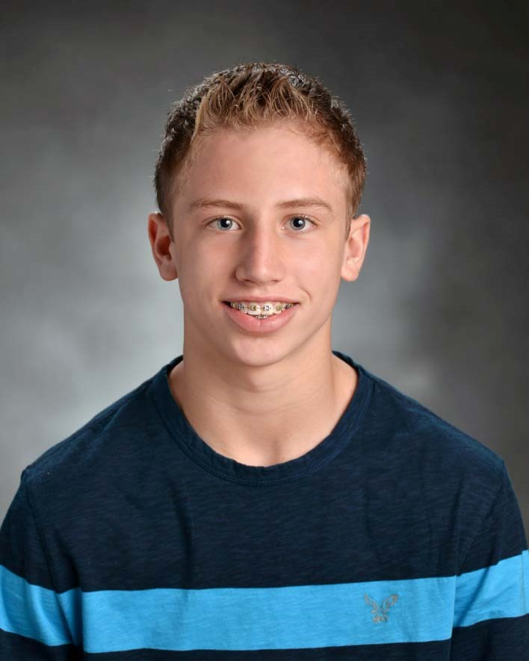
The Heitz 61 Memorial Foundation was created through the eyes of Ryan and will help others within the community by promoting higher education and encouraging the physical well-being and teamwork of young people involved in sports. Through your support and care it is our hope to keep Ryan’s spirit alive forever by providing assistance to others that have a desire to be exceptional. This is what Ryan would have wished for.
